**AUDIT COURSE**

**ELECTRONIC CIRCUITS 1: SIMULATION BASED STUDY**

**LAB 4**

Kindly update your name and roll no, once this document is shared with you

Time slot to complete your work is **40 MINUTES**

**Date: 11/8/2020**

Kindly upload your schematic & waveform images here, every 10 minutes, indicating your progress and intention to completion of WORK within time slot allotted

**Time slot allotted to you all for the completion of WEEK 2 DAY 2 is 40 MINUTES**

**Kindly upload your work (only circuit schematic & waveform in LTSpice) in the shared google doc between this time slot only.**

**Follow these instruction strictly:**

1, Start sharp ON TIME, by posting your name and roll no and **screenshot of your LT spice work screen ( time and date MUST BE VISIBLE)**

2. Upload your work every 10 minutes, i.e LT spice work screen

3. This means you will upload LT spice work screen 4 times during this time slot.

4. Point 3 indicates your readiness and presences for completion of WEEK 2 DAY 2

**You are entitled for 1 CREDIT per Lab only if you follow above instruction to the details**

**STUDENTS WORK AREA STARTS HERE**

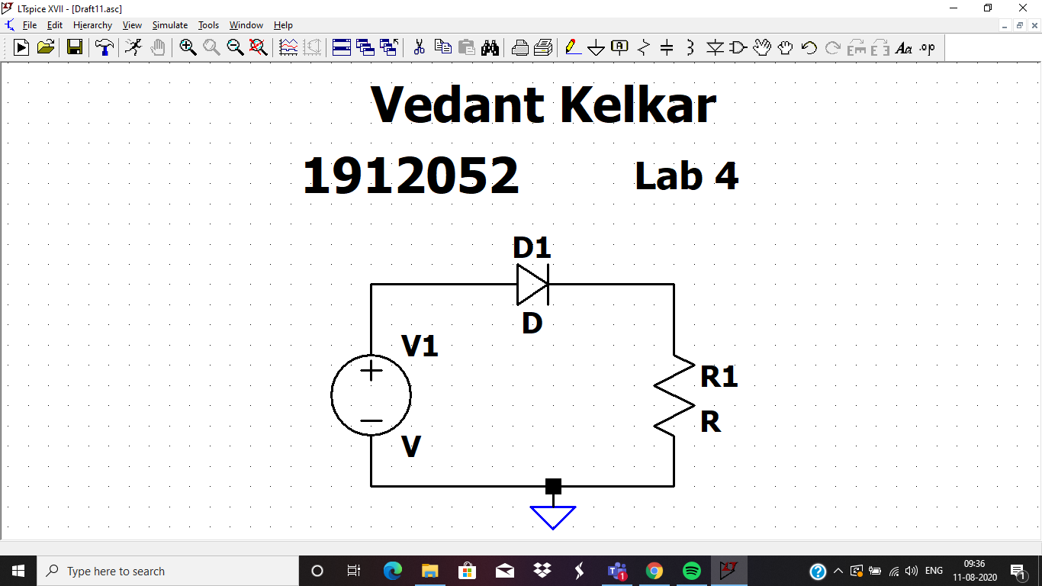

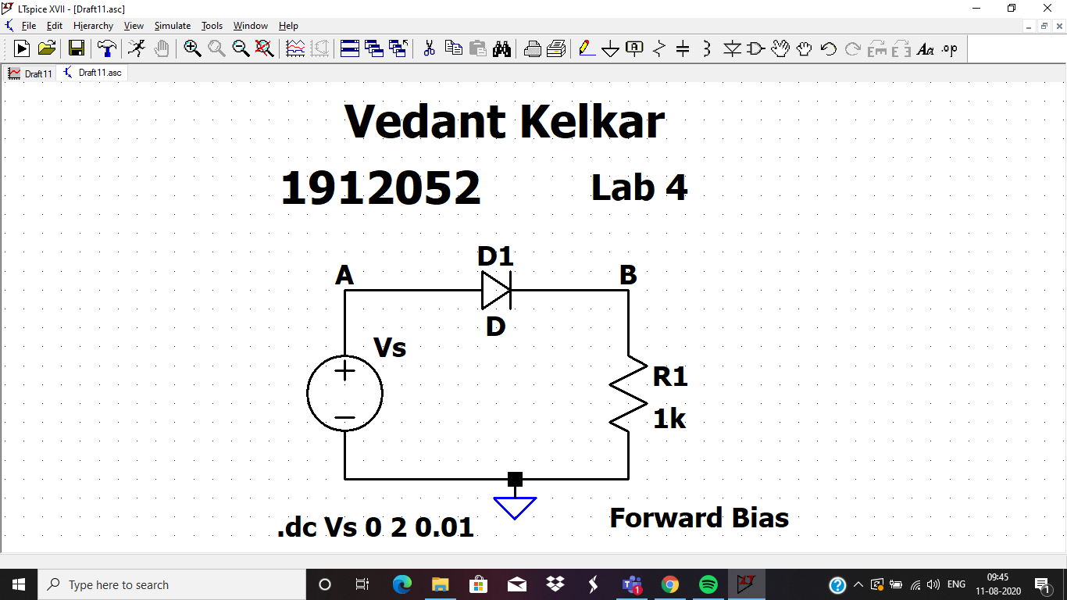

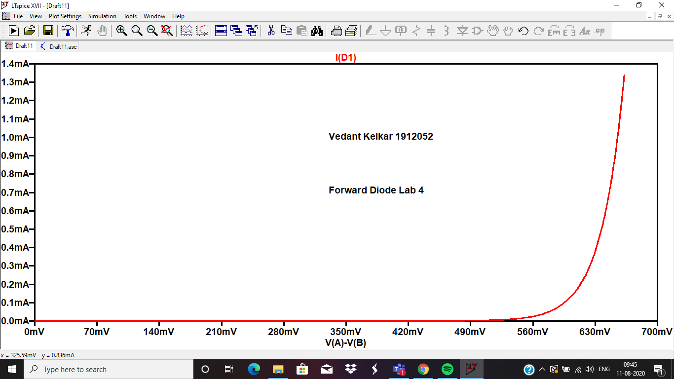

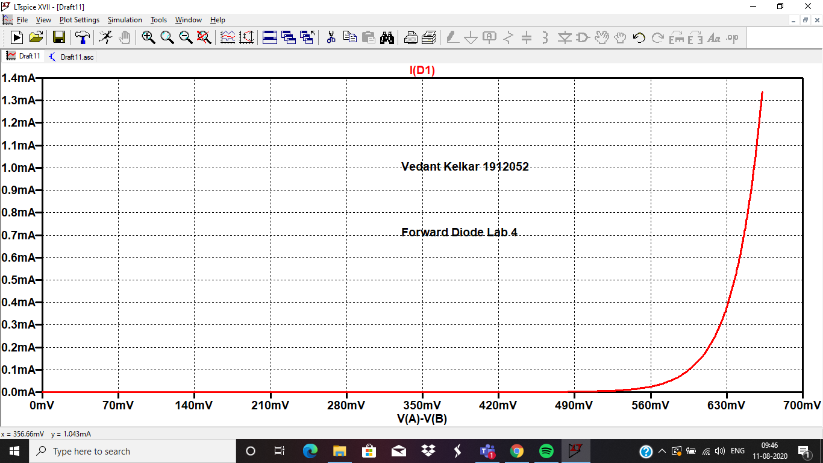

|  |  |  |
| --- | --- | --- |
| Sr No. | VD1 | ID1 |
| 1 | 300mV | 1.0939423nA |
| 2 | 500mV | 2.549363µA |
| 3 | 600mV | 119.45523µA |
| 4 | 620mV | 264.13863µA |
| 5 | 650mV | 822.97668µA |

Knee Voltage is 602 mV

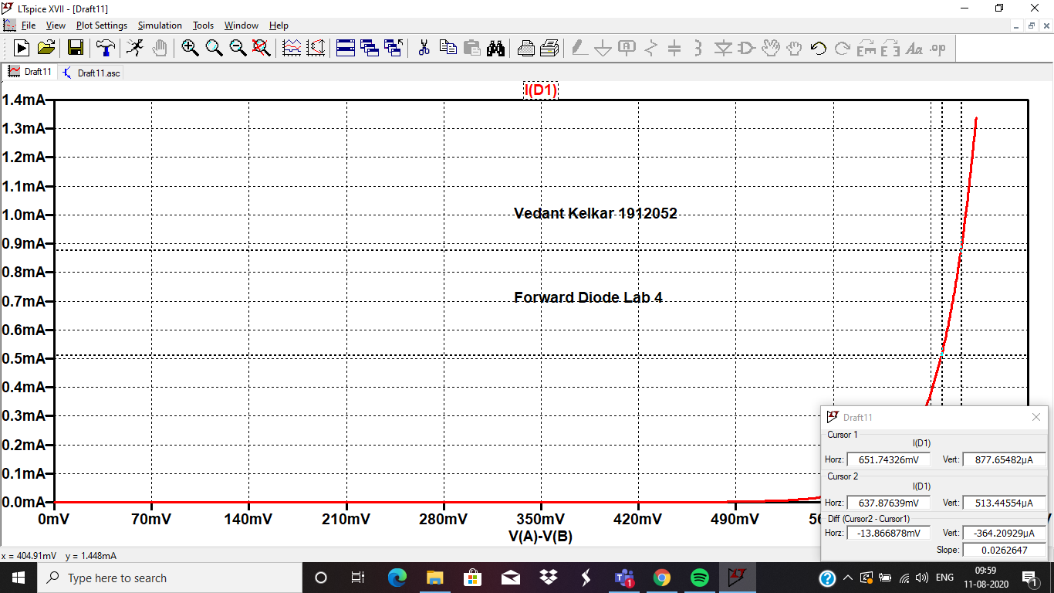

REVERSE BIAS

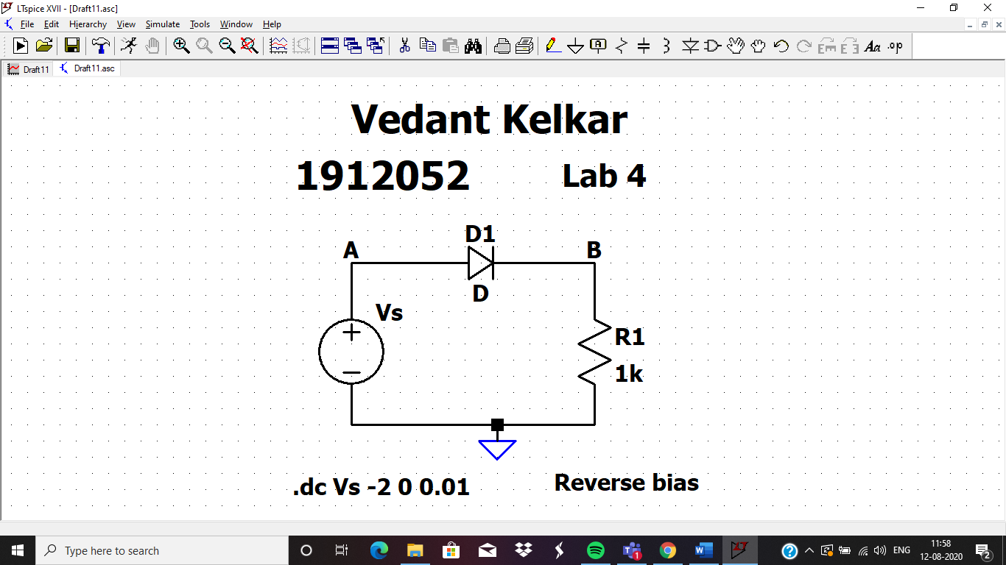

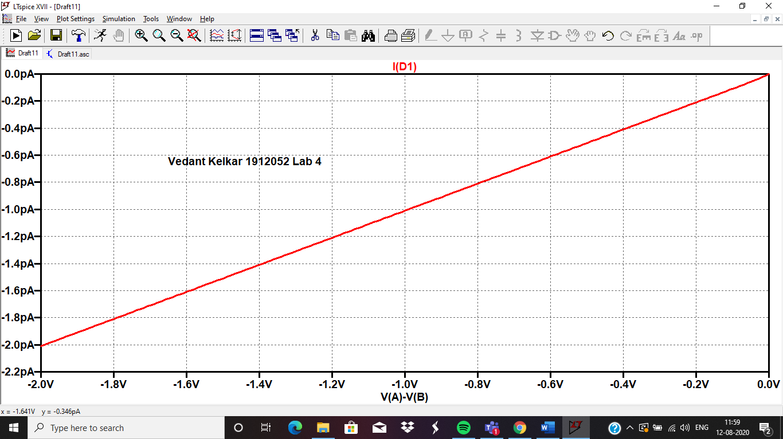

COMPLETE CURVE

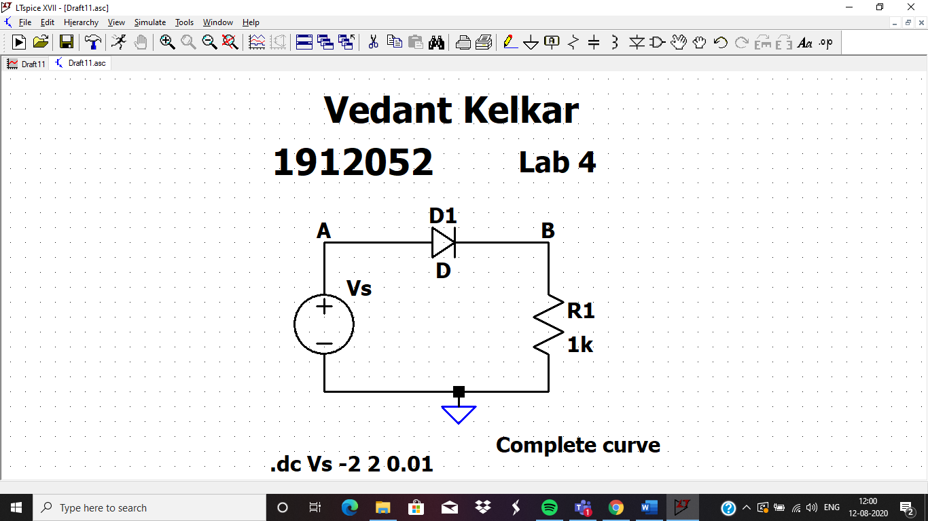

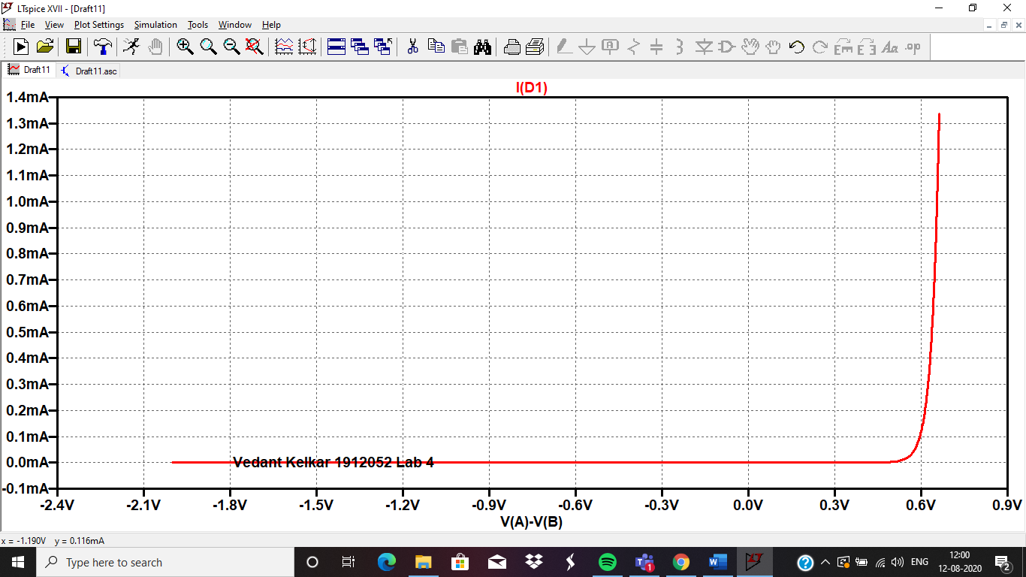

FORWARD BIAS 1N4148:::

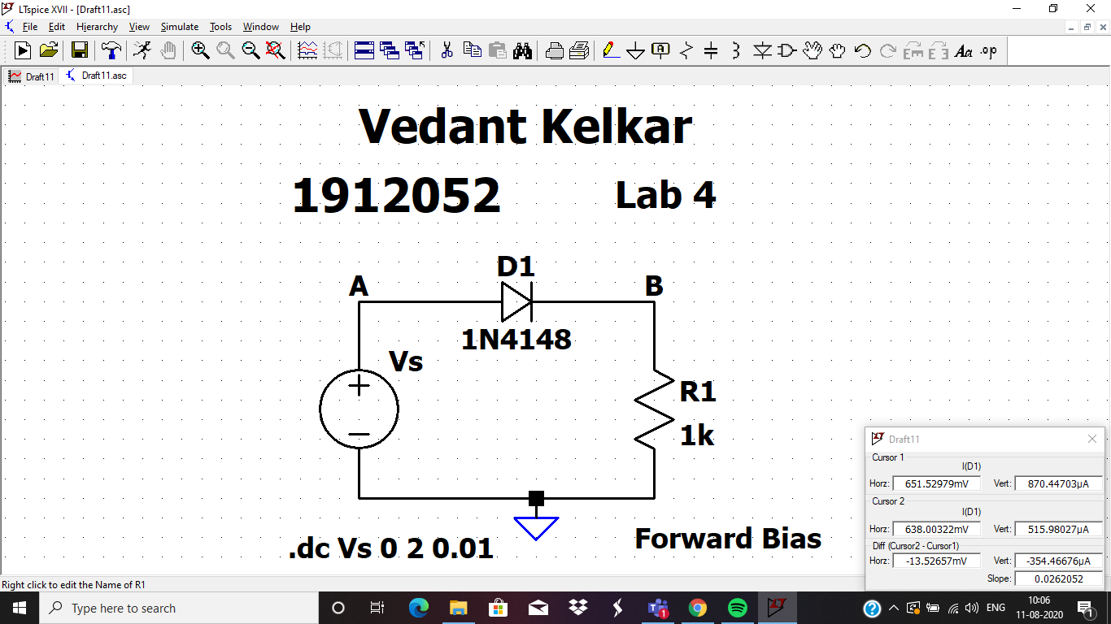

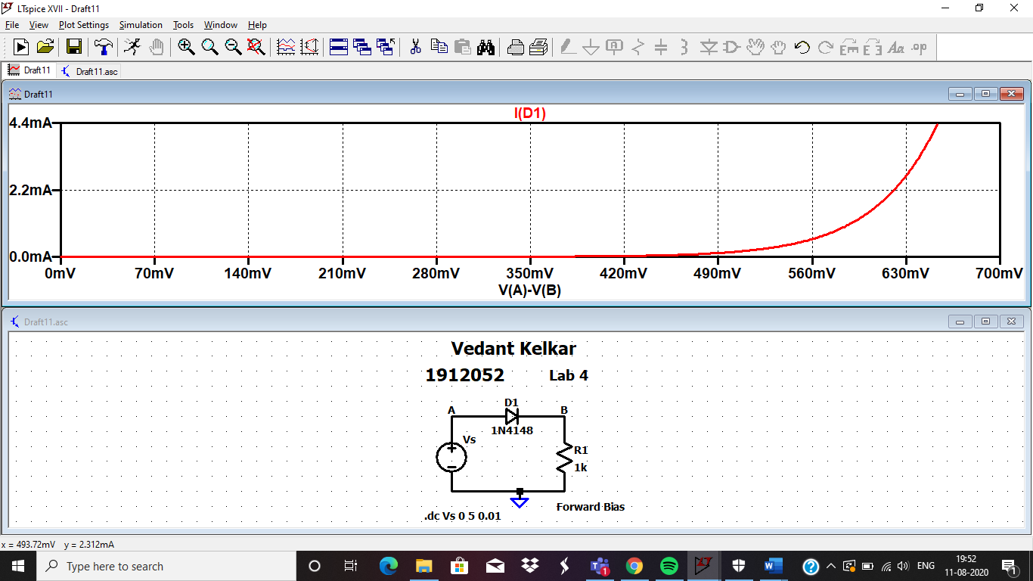

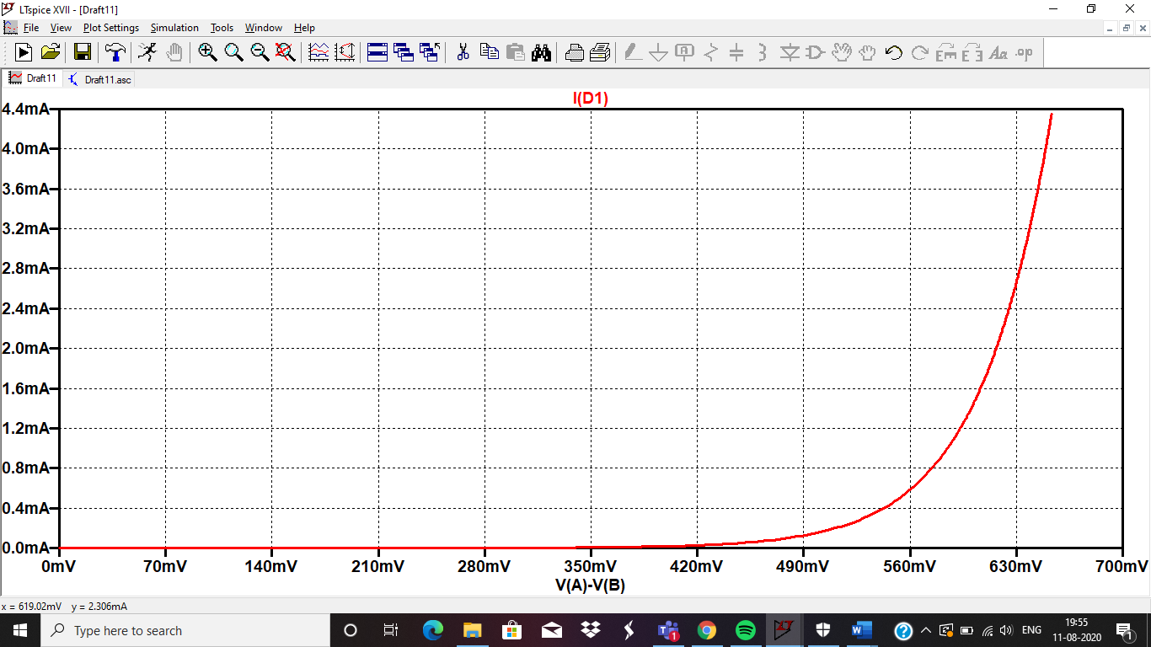

REVERSE BIAS 1N4148::::

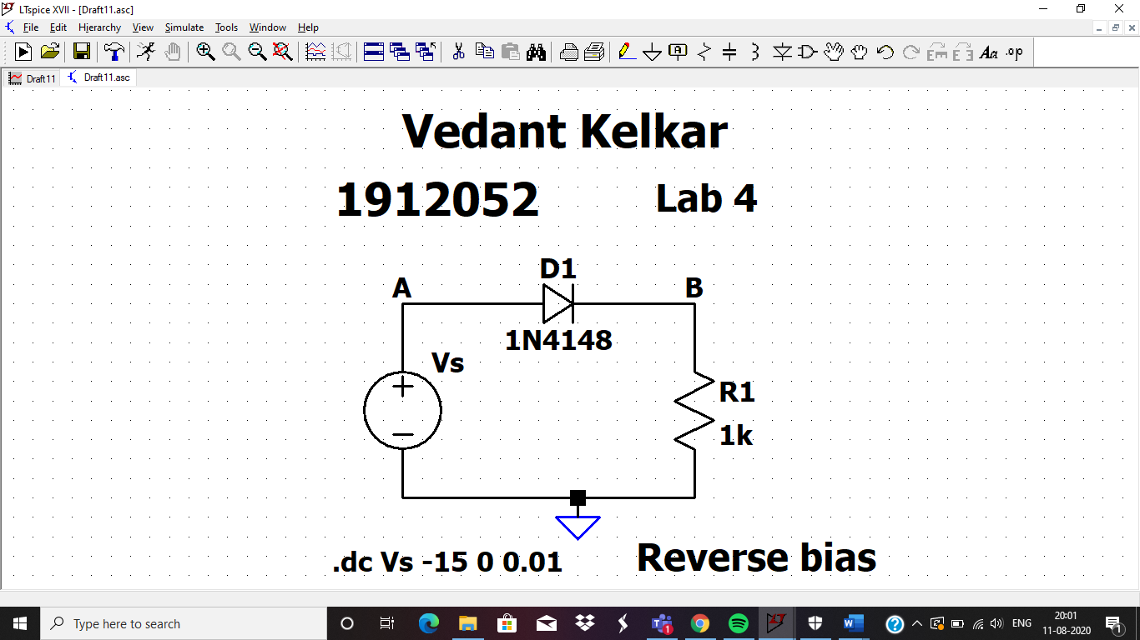

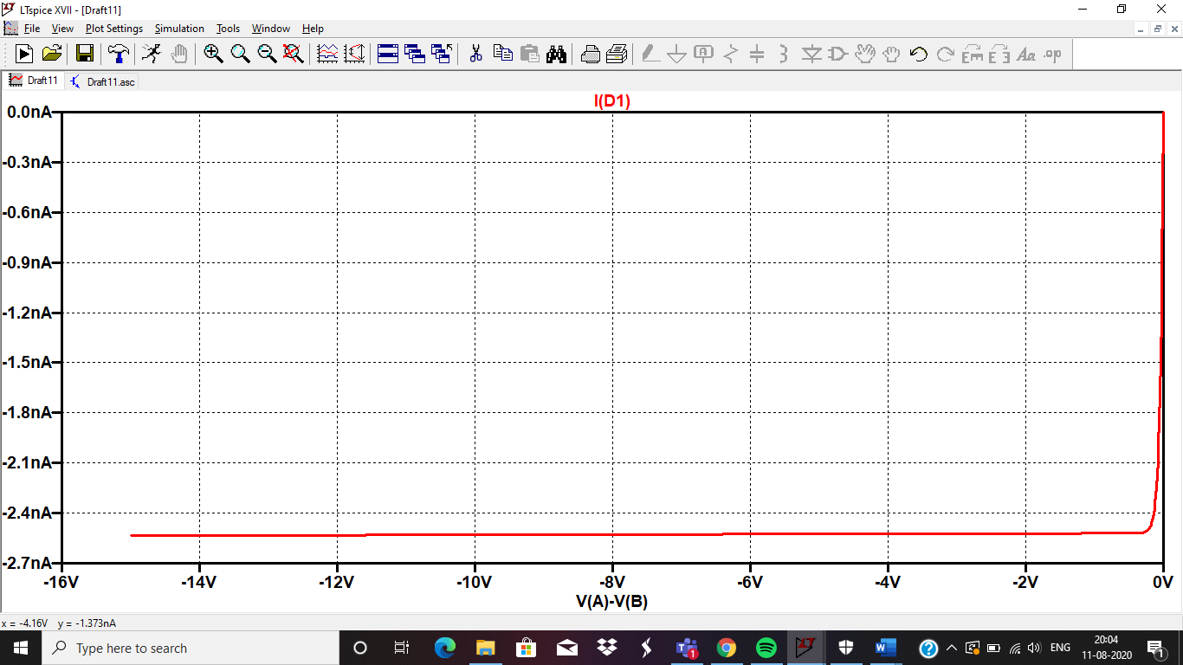

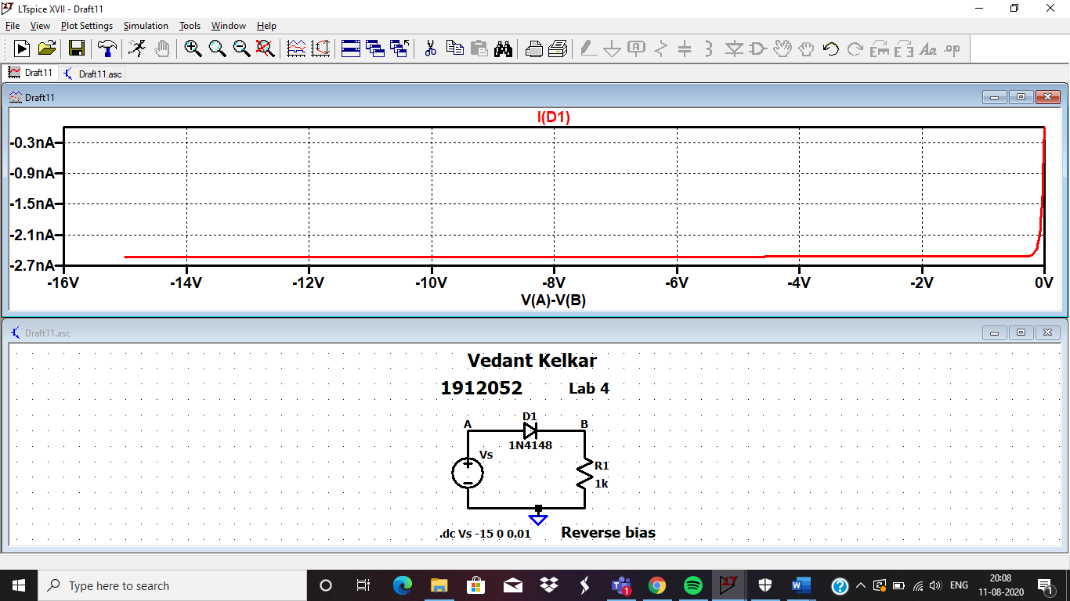

COMPLETE CURVE 1N4148::::

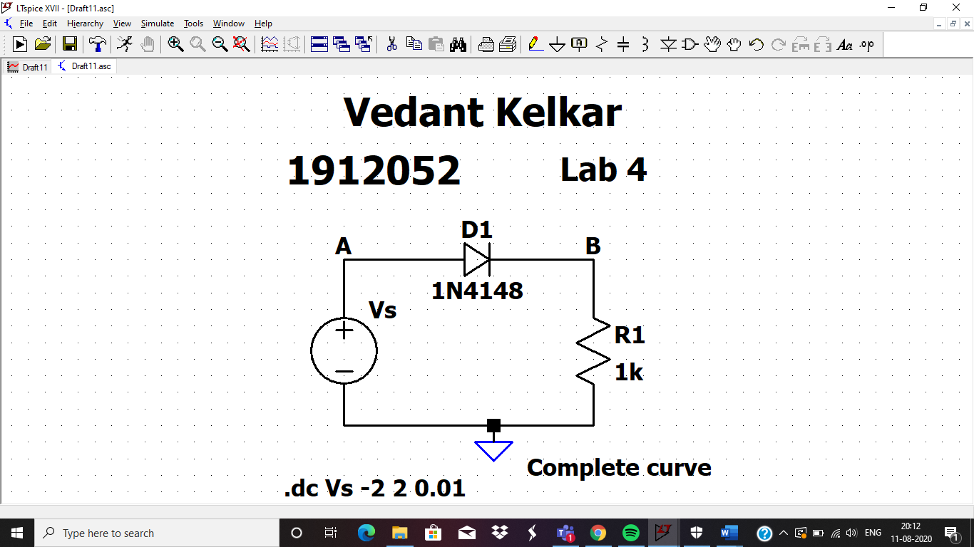

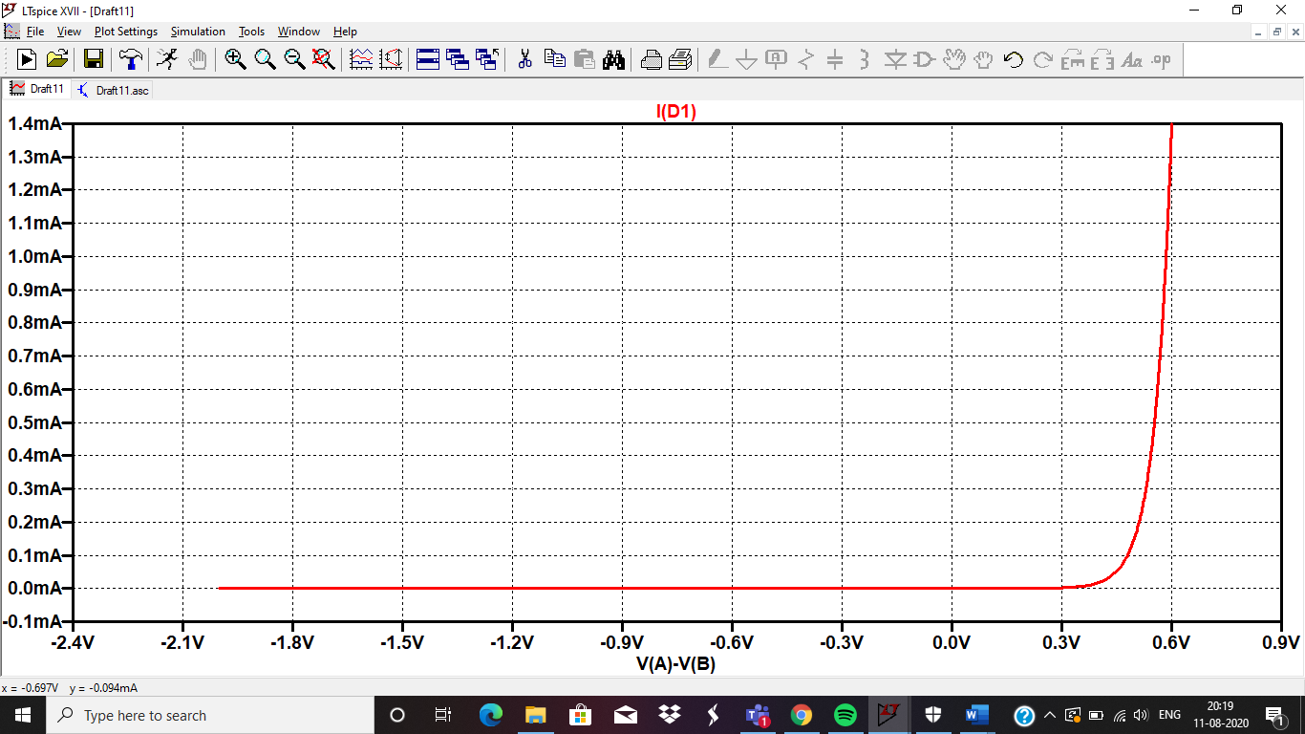

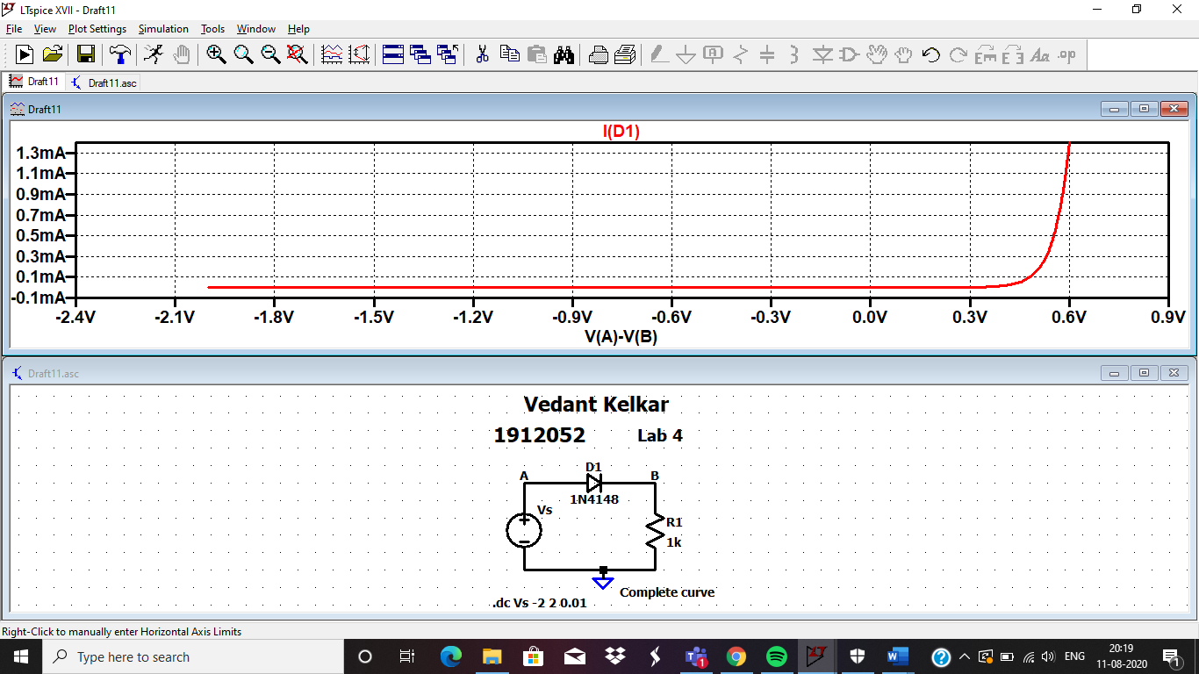

Suggestion: Always take either schematic full screen or waveform full screen, not both together.

ZENER DIODE FULL CURVE:::::

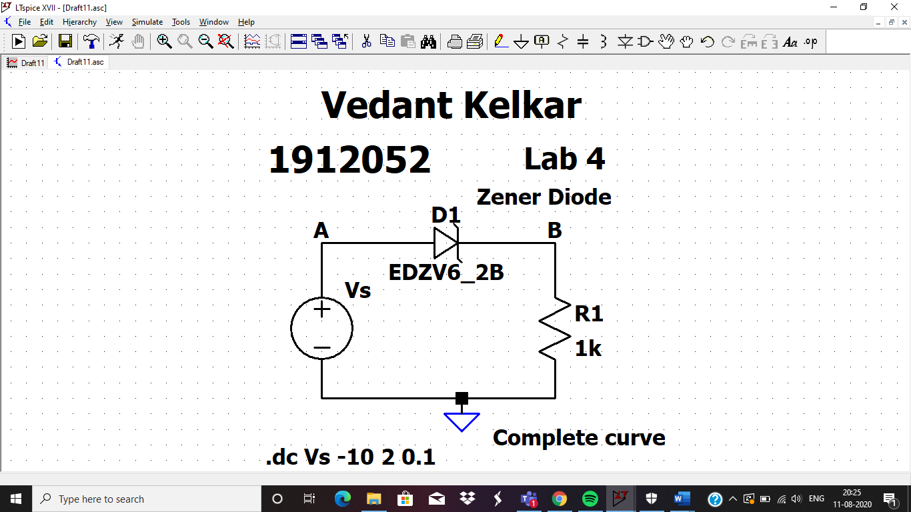

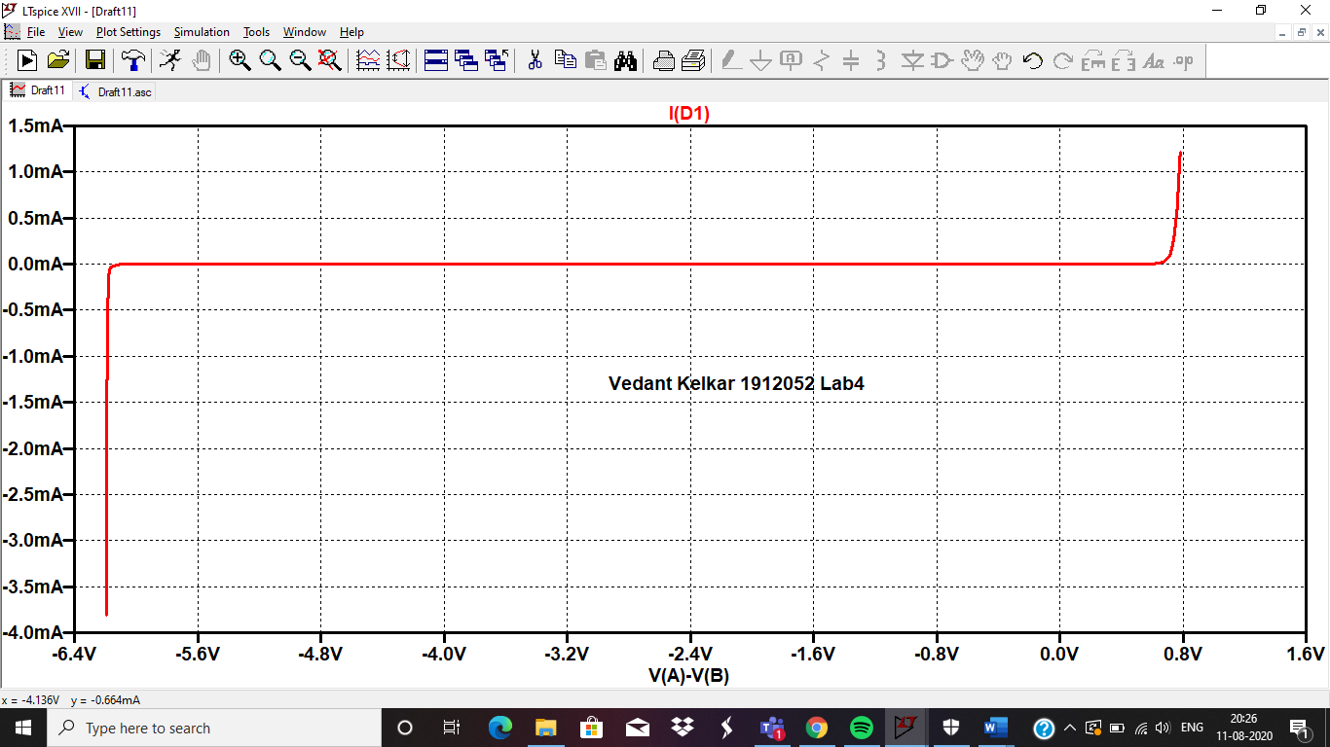

NETLIST CODE FOR NORMAL DIODE

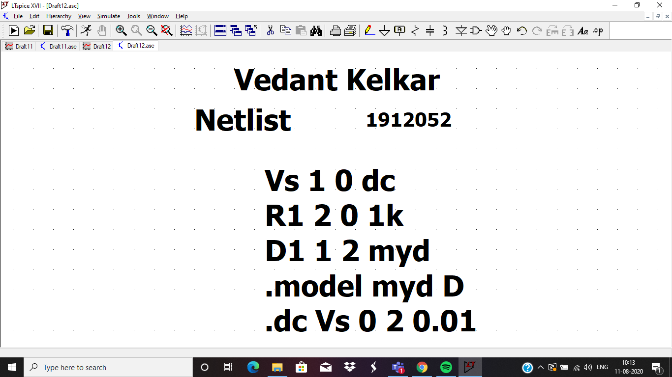

VERIFICATION OF THE CODE

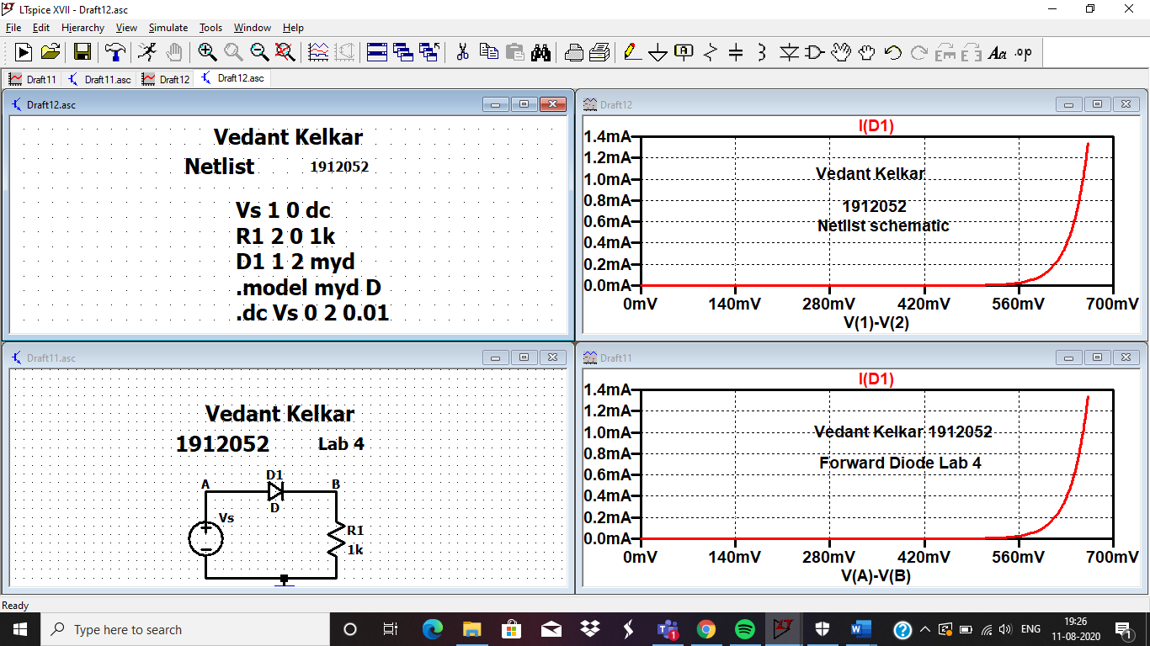

Suggestions: Calculate breakdown voltage of zener diode.

**LAB 4 is approved: Inderjit Singh Dhanjal**